電通二甲微處理器實驗 實驗結報

實驗名稱 | Labn11-MCS Cloud
組別 |  | 組員 | 06050704林智偉

- 實驗目的
運用MCS與arduino
- 實驗步驟
叫出範例程式碼，辦MCS帳號，修改範例碼，執行結果
- 程式碼
#1
#include <LWiFi.h>
#include <WiFiClient.h>
#include "MCS.h"

// Assign AP ssid / password here
#define _SSID "iPhone9"
#define _KEY "1234567890"

// Assign device id / key of your test device
MCSDevice mcs("DeuQ1VHM", "AMk0qaauln9pZjQW");

// Assign channel id
// The test device should have 2 channel
// the first channel should be "Controller" - "On/Off"
// the secord channel should be "Display" - "On/Off"
MCSControllerOnOff led("01");
MCSDisplayOnOff remote("02");

#define LED_PIN 7

void setup() {
// setup Serial output at 9600
Serial.begin(9600);

// setup LED/Button pin
pinMode(LED_PIN, OUTPUT);

// setup Wifi connection
while(WL_CONNECTED != WiFi.status())
{
Serial.print("WiFi.begin(");
Serial.print(_SSID);
Serial.print(",");
Serial.print(_KEY);
Serial.println(")...");
WiFi.begin(_SSID, _KEY);
}
Serial.println("WiFi connected !!");

// setup MCS connection
mcs.addChannel(led);
mcs.addChannel(remote);
while(!mcs.connected())
{
Serial.println("MCS.connect()...");
mcs.connect();
}
Serial.println("MCS connected !!");

// read LED value from MCS server
while(!led.valid())
{
Serial.println("read LED value from MCS...");
led.value();
}
Serial.print("done, LED value = ");
Serial.println(led.value());
digitalWrite(LED_PIN, led.value() ? HIGH : LOW);
}

void loop() {
// call process() to allow background processing, add timeout to avoid high cpu usage
Serial.print("process(");
Serial.print(millis());
Serial.println(")");
mcs.process(100);

// updated flag will be cleared in process(), user must check it after process() call.
if(led.updated())
{
Serial.print("LED updated, new value = ");
Serial.println(led.value());
digitalWrite(LED_PIN, led.value() ? HIGH : LOW);
if(!remote.set(led.value()))
{
Serial.print("Failed to update remote");
Serial.println(remote.value());
}
}

// check if need to re-connect
while(!mcs.connected())
{
Serial.println("re-connect to MCS...");
mcs.connect();
if(mcs.connected())
Serial.println("MCS connected !!");
}
}
#2
#include "MCS.h"

// Assign AP ssid / password here
#define _SSID "iPhone9"
#define _KEY "1234567890"

// Assign device id / key of your test device
MCSDevice mcs("DeuQ1VHM", "AMk0qaauln9pZjQW");

// Assign channel id
// The test device should have 2 channel
// the first channel should be "Controller" - "On/Off"
// the secord channel should be "Display" - "On/Off"

MCSControllerOnOff led("01");
MCSDisplayOnOff remote("02");
MCSDisplayInteger Temp("temp");

#define LED_PIN 7

void setup() {
// setup Serial output at 9600
Serial.begin(9600);

// setup LED/Button pin
pinMode(LED_PIN, OUTPUT);

// setup Wifi connection
while(WL_CONNECTED != WiFi.status())
{
Serial.print("WiFi.begin(");
Serial.print(_SSID);
Serial.print(",");
Serial.print(_KEY);
Serial.println(")...");
WiFi.begin(_SSID, _KEY);
}
Serial.println("WiFi connected !!");

// setup MCS connection
mcs.addChannel(led);
mcs.addChannel(remote);
mcs.addChannel(Temp);
while(!mcs.connected())
{
Serial.println("MCS.connect()...");
mcs.connect();
}
Serial.println("MCS connected !!");

// read LED value from MCS server
while(!led.valid())
{
Serial.println("read LED value from MCS...");
led.value();
}
Serial.print("done, LED value = ");
Serial.println(led.value());
digitalWrite(LED_PIN, led.value() ? HIGH : LOW);
}

void loop() {
// call process() to allow background processing, add timeout to avoid high cpu usage
Serial.print("process(");
Serial.print(millis());
Serial.println(")");
mcs.process(100);

// updated flag will be cleared in process(), user must check it after process() call.
if(led.updated())
{
Serial.print("LED updated, new value = ");
Serial.println(led.value());
digitalWrite(LED_PIN, led.value() ? HIGH : LOW);
if(!remote.set(led.value()))
{
Serial.print("Failed to update remote");
Serial.println(remote.value());
}
}

if(!Temp.set(analogRead(A0)))
{
Serial.print("Temp: ");
Serial.println(Temp.value());
}

// check if need to re-connect
while(!mcs.connected())
{
Serial.println("re-connect to MCS...");
mcs.connect();
if(mcs.connected())
Serial.println("MCS connected !!");
}
}

- 實驗結果及分析
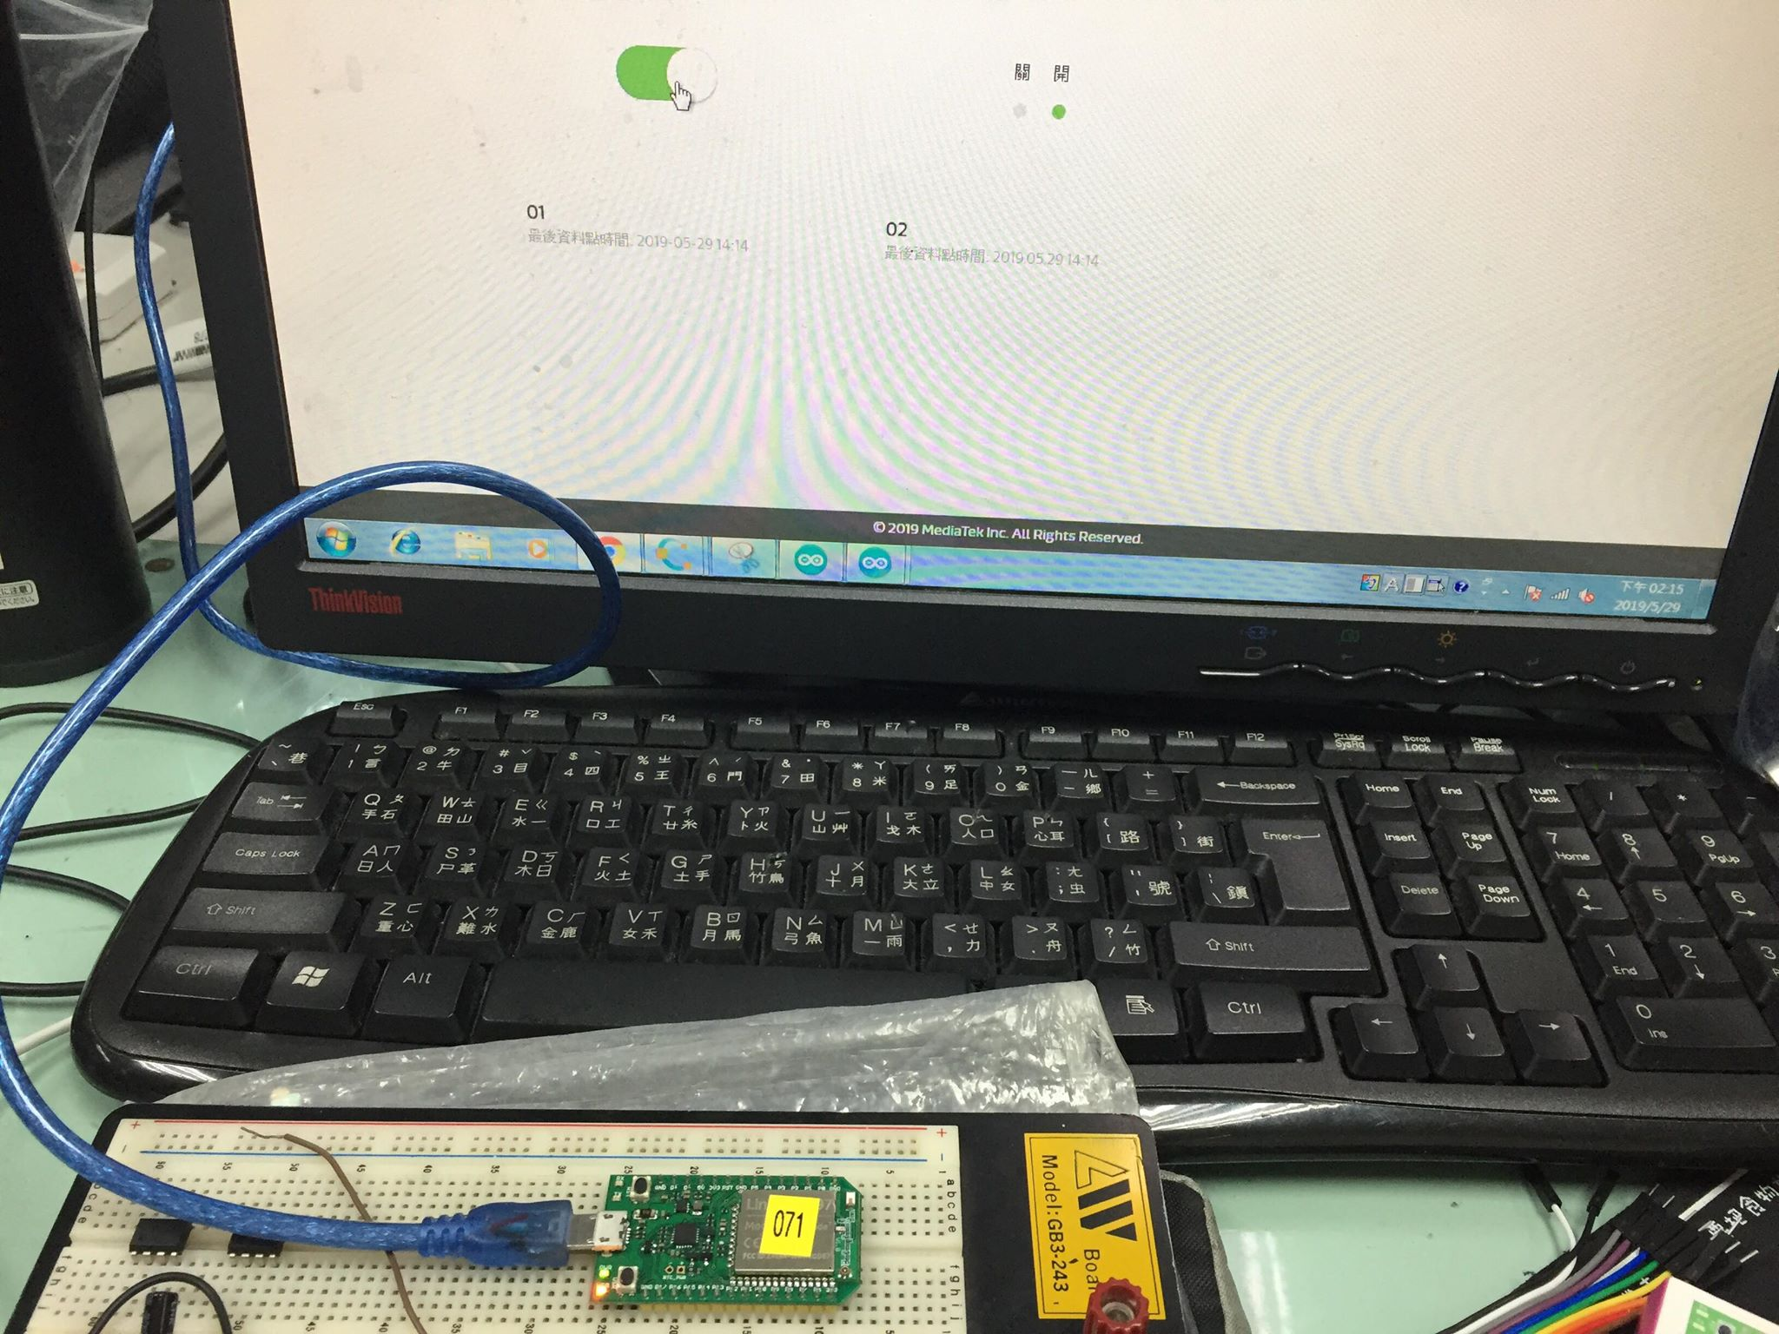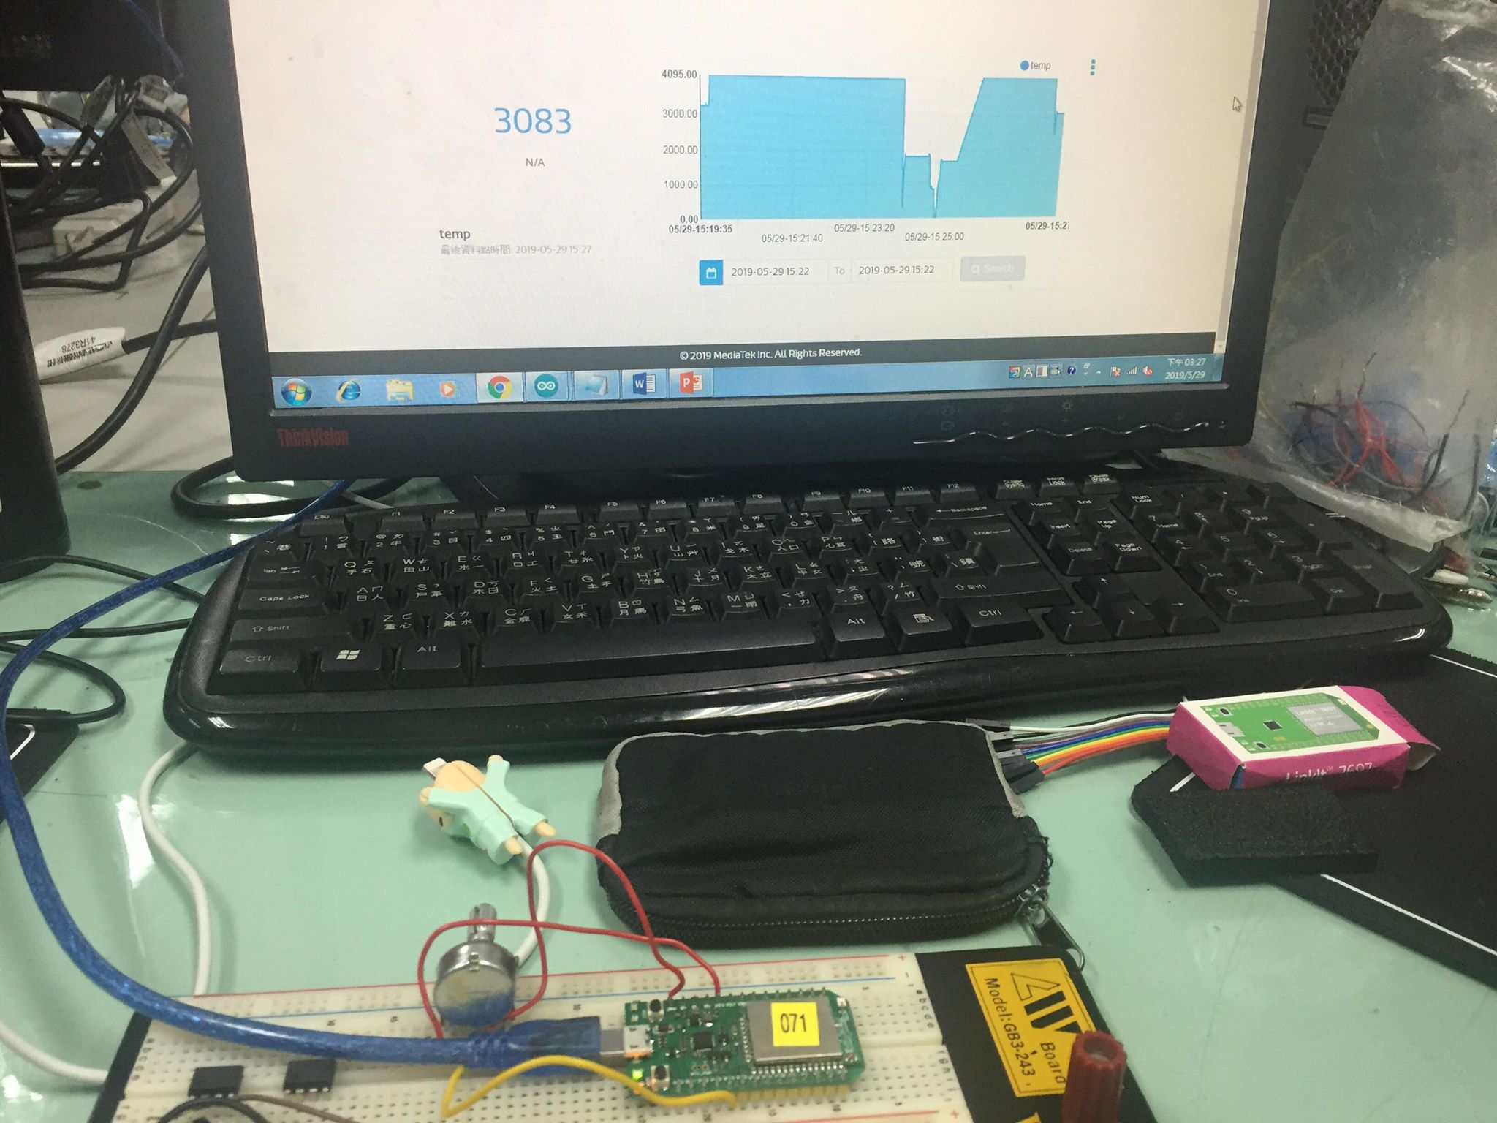
- 心得討論

這次的實驗非常的有趣，也不會很難，很開心

